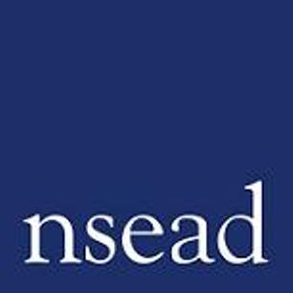
The National Art and Design Education Conference
Leading better practice for art, craft and design educators across the UK

2025 Conference: Designing a learner-centred & contemporary curriculum

Name of teacher requesting CPD | (Teacher to complete)
Focus of this conference: | NSEAD’s Annual Conference brings together art educators from across the UK, from all phases and sectors engaged in art, craft and design education. A key event in your calendar, the conference is your opportunity to keep up to date with the latest developments for our subject, connect with others and exchange ideas.
What will attendees learn? | The programme combines inspiring presentations, with the latest research and information to help you to design a learner-centred and contemporary curriculum. Workshop sessions will provide an active space for you to develop your own professional practice, with learning that you will take directly back to the classroom.
How will this develop professional practice for specialist art, craft and design teachers? | - Improve your confidence to design and deliver an exciting art and design curriculum that is right for your learners  - Access new resources and tools  - Discover practical solutions for your curriculum challenges  - Enhance your skills with artist-led workshops  - Stay updated on curriculum developments  - Connect with a supportive professional network  - Be inspired, refreshed, enthused  - Ask questions, get the answers you need  - Lead our subject with confidence

For teachers to complete
How will my students benefit? | (May relate to: Embedding skills, knowledge and understanding; progress and achievement; motivation; aspiration, positive attitudes; community engagement; transferrable skills)
How will my learning contribute to whole school improvement priorities? | (May relate to: Behaviour and attitudes, attendance, personal development, leadership and management, improving staff’s subject, pedagogical and pedagogical content knowledge; curriculum development, assessment, community engagement, workload and well-being, equity, diversion and inclusion)
Links to performance review and personal development goals:

Cost: | NSEAD member (Registration fee only): £10  Non member: £125 Early Bird rate | £145 Standard rate  Non members can register for a year’s full membership to attend for free, find out more here: https://www.nsead.org/membership/membership-benefits-2025/

